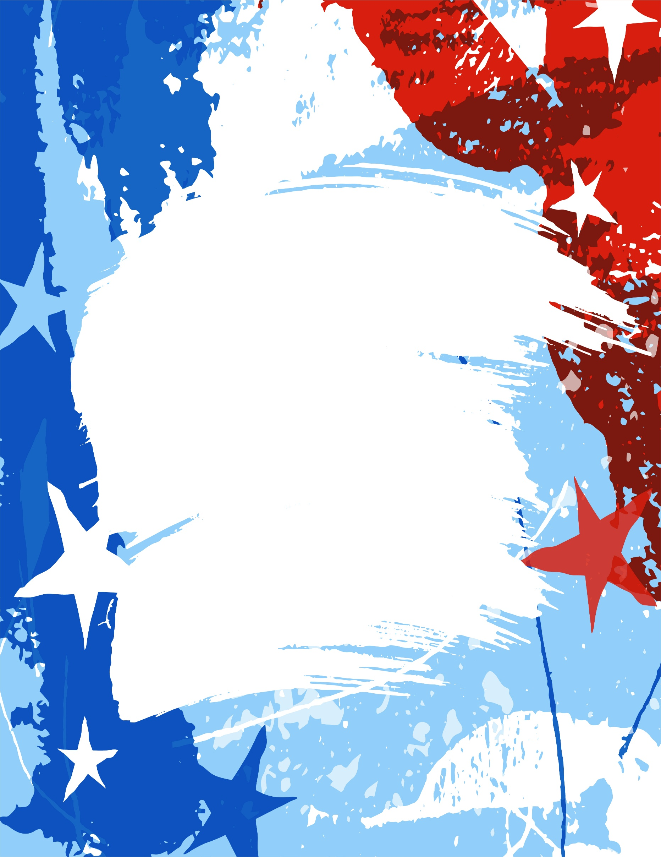
Tuesday, April 7, 2026
4:00pm – 5:00pm Seminar Registration Desk – Omaha Marriott @ Regency
5:00pm – 7:00pm Hospitality & Networking – Sponsored by FaceTec

Wednesday, April 8, 2026

7:00am – 8:00am Seminar Registration Desk – Omaha Marriott at Regency
8:00am – 8:20am Opening Remarks; Nicole Mann, IA/NE IASIU President
Presidential Sponsor Introductions (CoventBridge Group & Great Plains Reporting)
Iowa & Nebraska Department of Insurance Updates
ALL GROUP SESSION
8:30am – 9:30am Generative AI’s Role in Reshaping Insurance Investigations
Joe Stephenson, Lemieux & Associates
9:30am – 9:45am Break (Visit the Vendors)
MEDICAL BREAK-OUT SESSIONS
9:45am – 10:35am Unbundling with Spinal Injections
Tami Rockholt, Rockholt & Associates
10:35am – 10:50am Break (Visit the Vendors)
10:50am – 11:40am Strategically Investigating Your Claims with Unmanned/Remote Surveillance
John Wichmann, PhotoFax Inc.
11:40am – 12:40pm Lunch (Provided)
12:40pm – 1:30pm Organized Medical Fraud
Eric Moch, HelperBroom LLC
1:30pm – 1:40pm Break (Visit the Vendors)
1:40pm – 2:30pm ID Verification
Zac Sheldon, Thomson Reuters
2:30pm – 2:40pm Break (Visit the Vendors)
2:40pm – 3:30pm Medicaid Fraud and Financial Exploitation
Mark Collins, Director, Medicaid Fraud and Patient Abuse Unit, Nebraska Attorney General’s Office
3:30pm – 3:40pm Break (Visit the Vendors)
3:40pm – 4:30pm Leveraging Technology in Investigations
Scott MacDuffee, Advantage Investigations
P&C BREAK-OUT SESSIONS
9:45am – 10:35am Let’s Get Digital!
Kim Downey, Complete Investigations
10:35am – 10:50am Break (Visit the Vendors)
10:50am – 11:40am NE DMV Fraud Unit Overview and Vehicle Cloning
Glenn Elwell, Nebraska DMV Fraud Unit
11:40am – 12:40pm Lunch (Provided)
12:40pm – 1:30pm Case Studies: The Hidden Power of Forensic Accounting
Rachel Young and Keith Seiffert, Pario Forensics
1:30pm – 1:40pm Break (Visit the Vendors)
1:40pm – 2:30pm The Hidden Spark: Exposing Fraud through a Fire Inv.
Kerri Hoogendoorn, Michael Ling, John Ticer, EFI Global
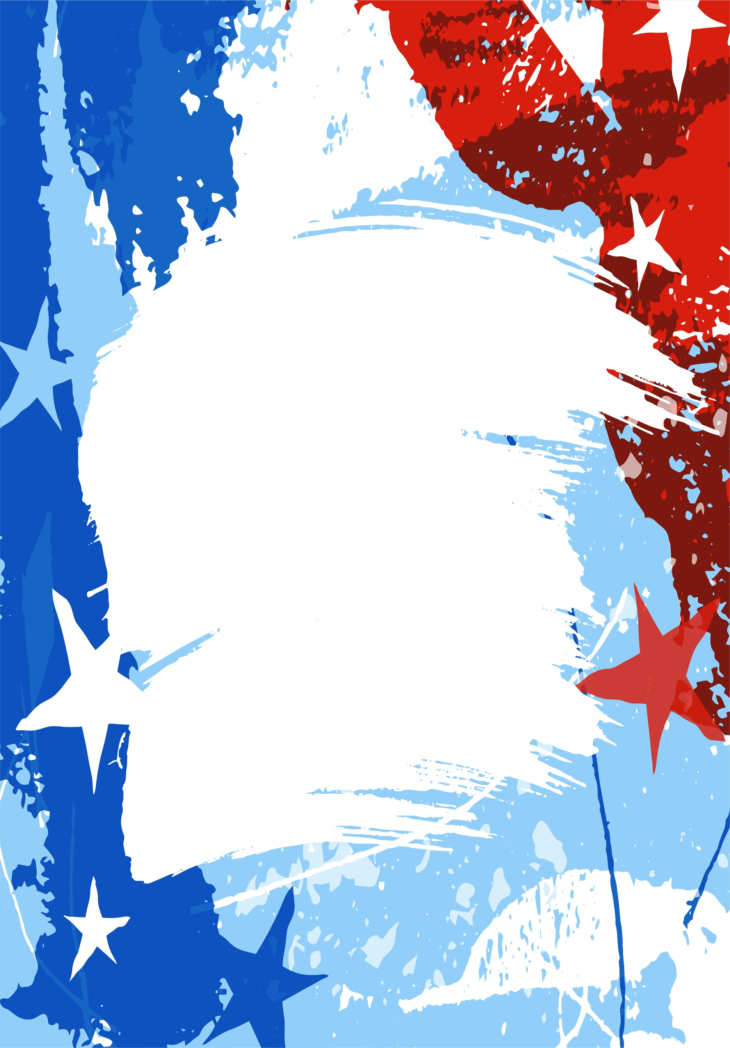
2:30pm – 2:40pm Break (Visit the Vendors)
2:40pm – 3:30pm Crash Con: Spotting Staged Auto Accidents Garrett Boeckeler, Becker and Company
3:30pm – 3:40pm Break (Visit the Vendors)
3:40pm – 4:30pm Protect the Bottom Line From Fraudsters
Matt Badgerow, TransUnion

4:30pm – 6:00pm President’s Reception – Appetizers & Refreshments
Sponsored by CoventBridge & Great Plains Reporting
6:00pm – 10:00pm Hospitality & Networking – (Room TBA)
Sponsored by FaceTec

Thursday, April 9, 2026

7:30am – 8:00am Seminar Registration Desk – Omaha Marriott at Regency
8:00am – 8:30am Annual Board Meeting (IA/NE IASIU Chapter Members)

ALL GROUP SESSION
8:45am – 9:00am Opening Remarks; Nicole Mann, IA/NE IASIU Chapter President
Gold Sponsor Introductions (National Fire Experts, Wandling Engineering, Contego, IFIC)
9:00am – 9:15am Break (Visit the Vendors)

MEDICAL BREAK-OUT SESSIONS
9:15am – 10:05am The Power of Detail: Effective Low-Impact Commercial Investigations (Panel)
Adam Brand - Brand and Tapply, LLC, Bill King - Impact General, Don Kohtz - Markel Insurance
10:05am – 10:15am Break (Visit the Vendors)
10:15am – 11:05am From Claim to Conviction: Inside the Medical Fraud Pipeline
Amy Phelps, NICB
11:05am – 11:15am Break (Visit the Vendors)
11:15am – 12:05pm From Claims to Clues: Inside Medical Review Investigations
Tom Ceres, CoventBridge Investigations
12:05pm – 1:00pm Lunch (Provided)

P&C BREAK-OUT SESSIONS
9:15am – 10:05am TBA
Peter J. Vaccaro, Midwest Regional Director - Forensic Services | NV5
10:05am – 10:15am Break (Visit the Vendors)
10:15am – 11:05am The Investigator’s Edge: Interviewing for Impact
John Sargent and Frank Sztuk, Delta Group
11:05am – 11:15am Break (Visit the Vendors)
11:15am – 12:05pm TBA
Steve Jones, Carfax
12:05pm – 1:00pm Lunch (Provided)
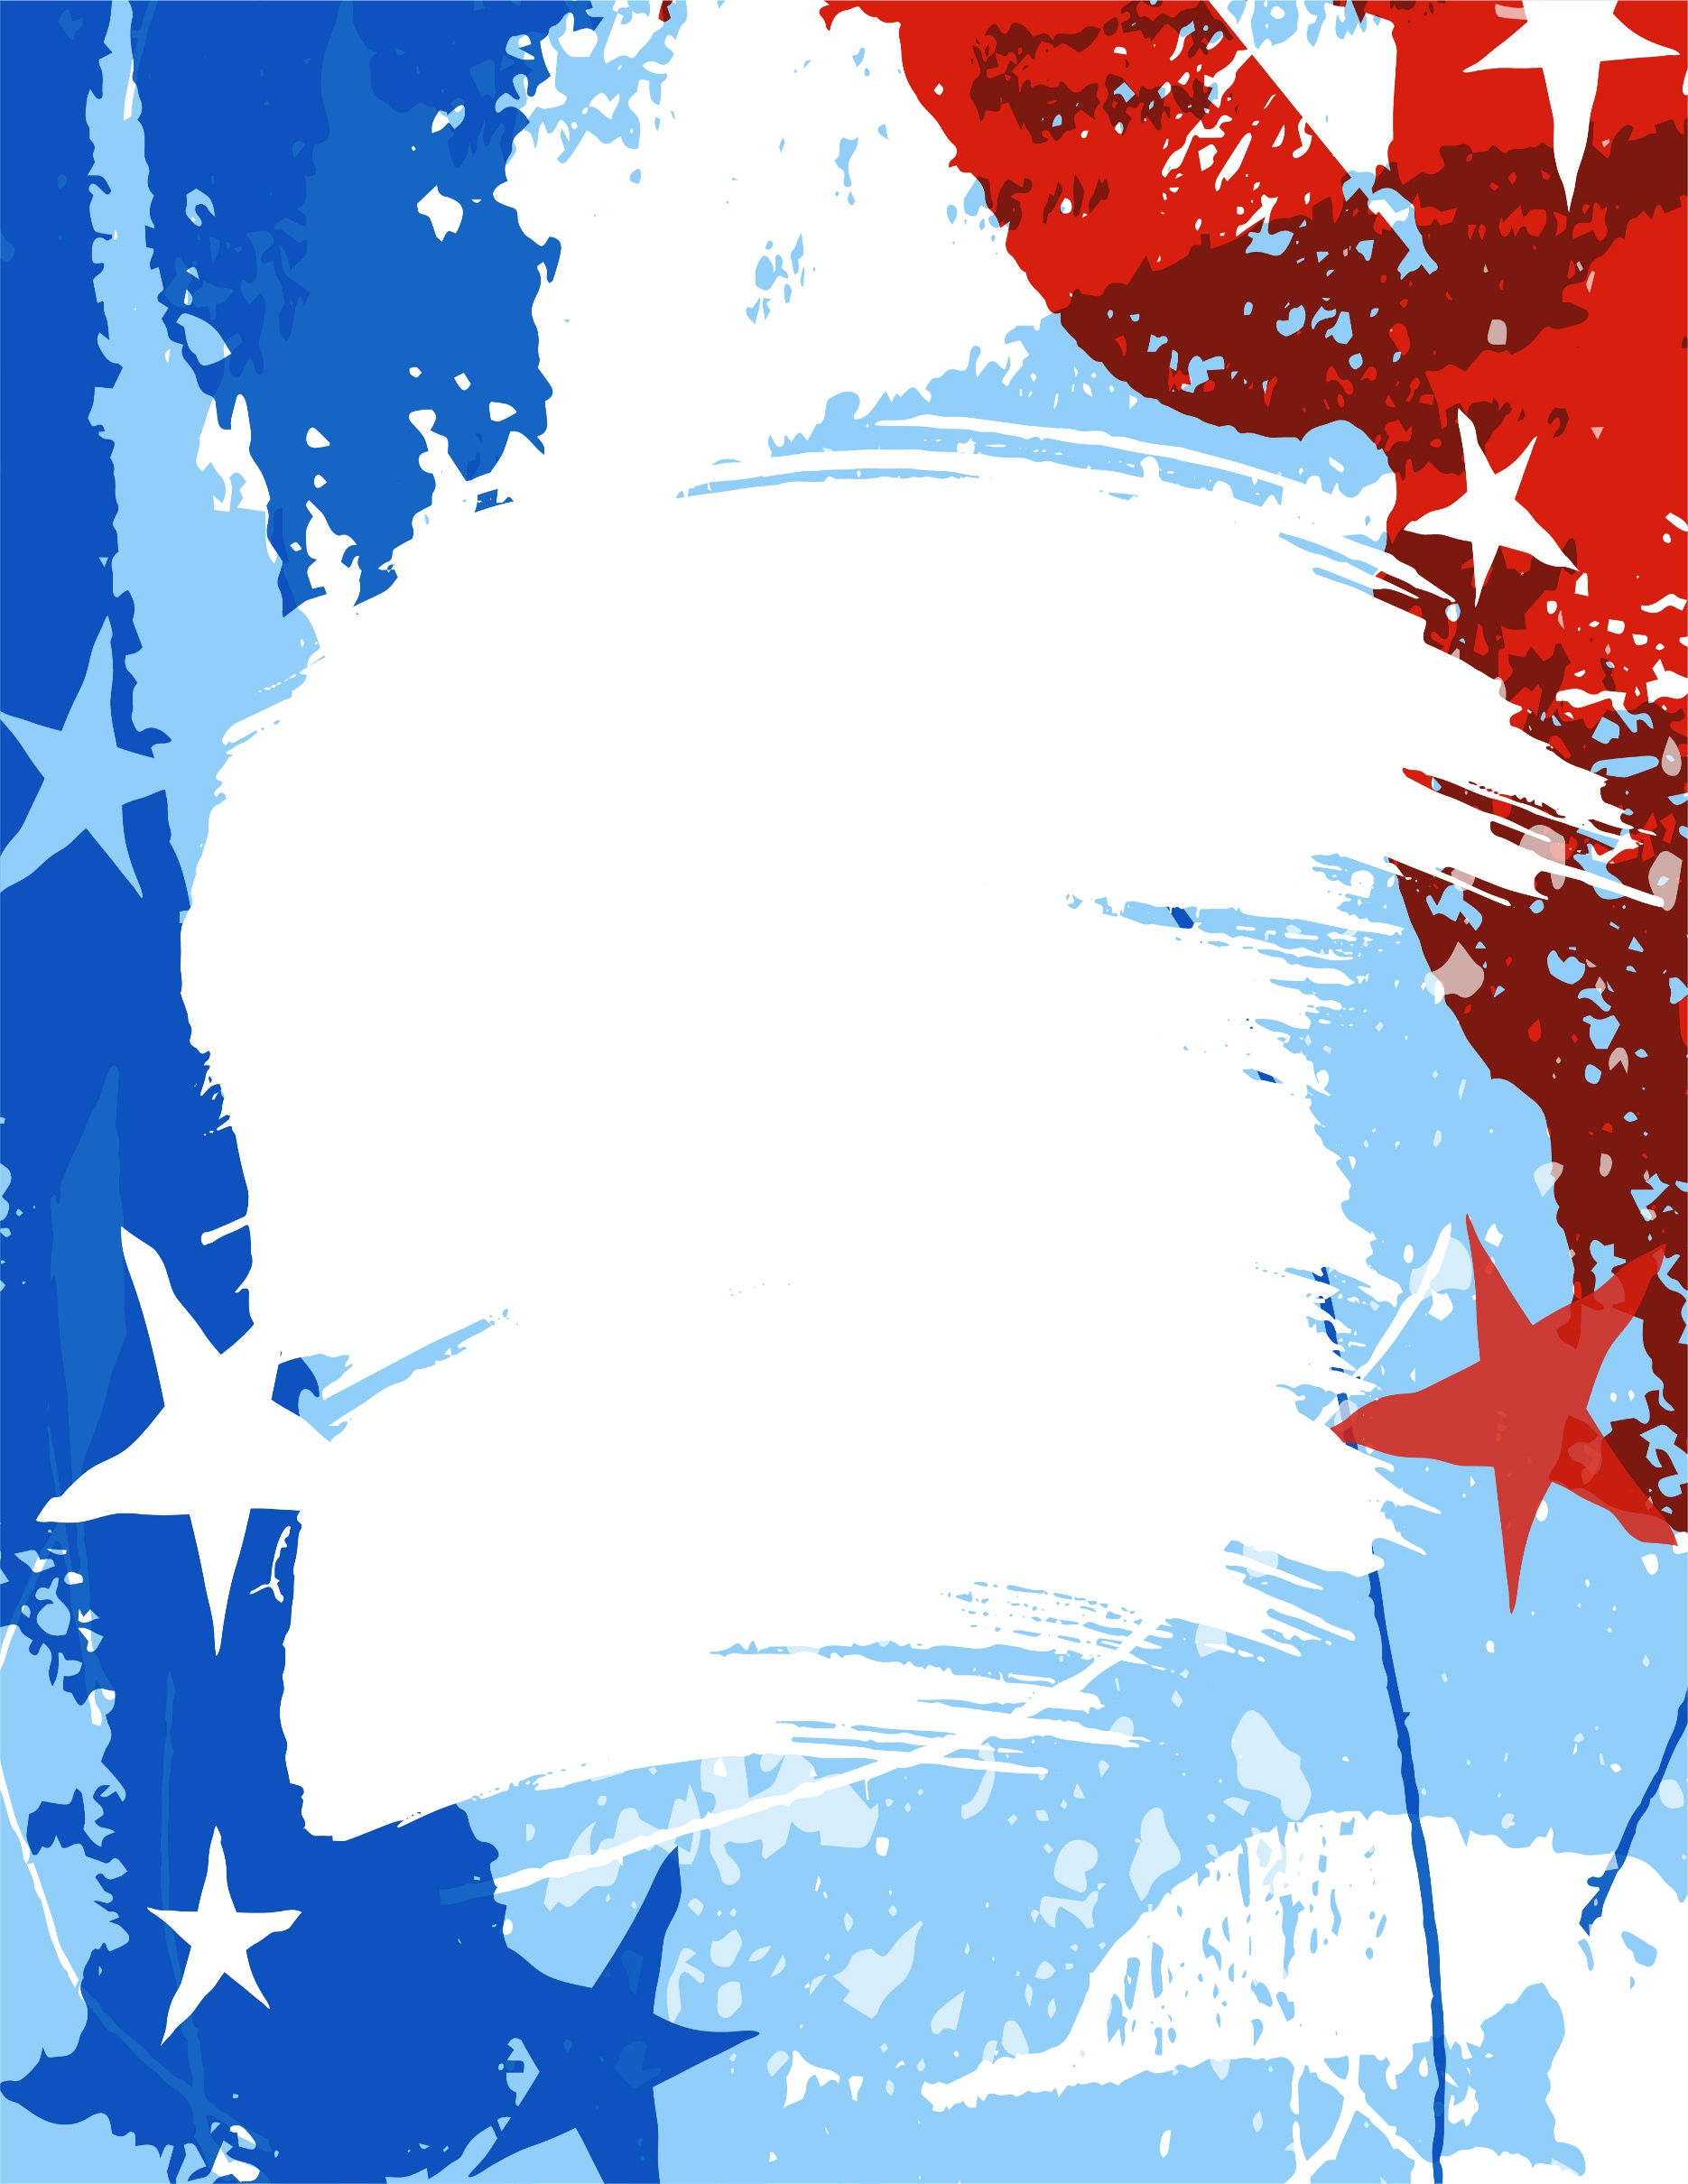
ALL GROUP SESSION

1:00pm – 1:50pm Emerging Fraud Trends (Ethics)
Gus Hitz, NICB
1:50pm – 2:10pm Vendor Drawings
2:20pm – 3:10pm Investigating with Integrity: The Ethics Advantage (Ethics) Jonathan Colman, Colman Law Group
3:10pm – 4:00pm Hammering Out the Truth: Tackling Contractor Fraud (Ethics)
Kim Semler, NE DOI Chief and Matt Mortvedt, IA DOI Chief

4:00pm Adjourn: Certificates of Attendance Distributed

**** Happy Hour: 4:00-6pm: TBA ****

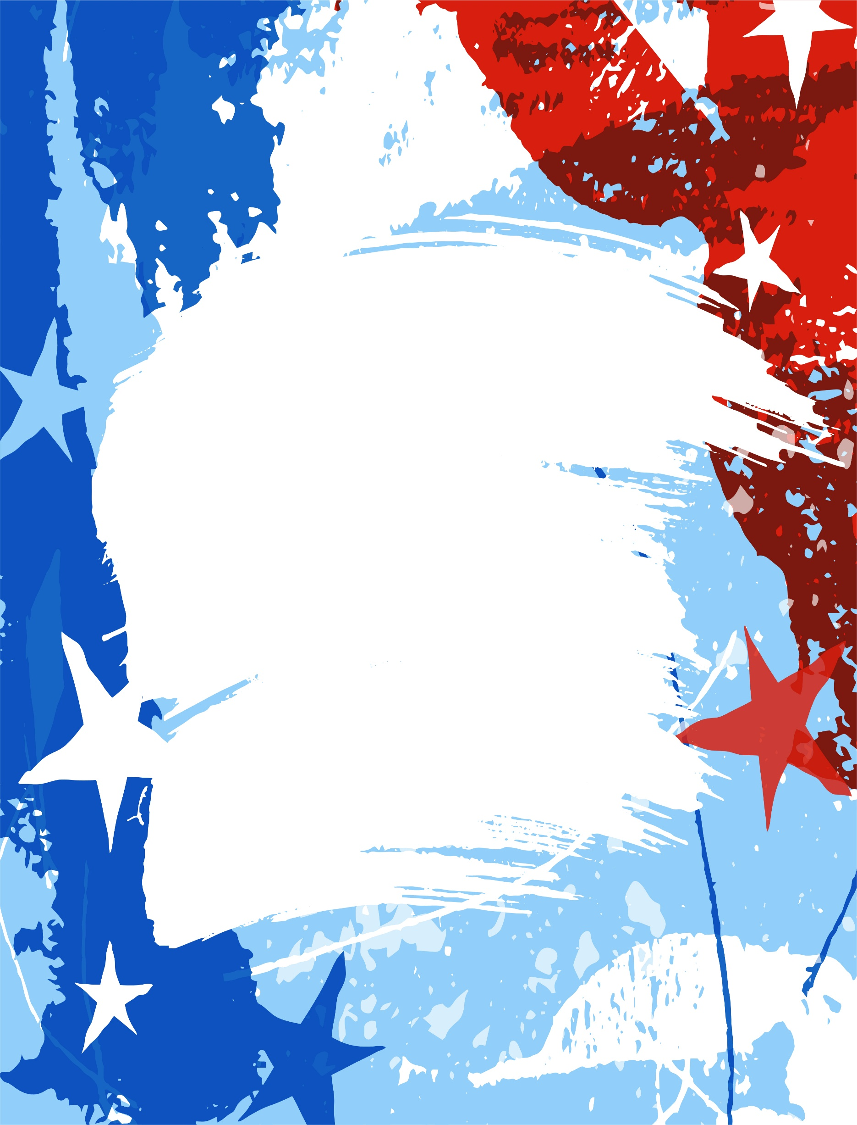
REgisTER AND PAY ONLINE at: https://www.ia-neiasiu.com/online-registration
Or complete paper registration form and mail a check to:
IA-NE IASIU
PO Box 304
Boys Town, NE 68010

IA-NE IASIU Training Seminar Registration Form

Name: ____________________________________________________________
Company/Agency: __________________________________________________
Address: __________________________________________________________
City: _____________________________________________________________
State/Zip: _________________________________________________________
Daytime Phone: ____________________________________________________
Email: ____________________________________________________________
🍽 Check all that apply:
 Attending President’s Reception
 Requesting Vegetarian Lunch
 Requesting Gluten-Free Lunch
Registration Fee: Before 3/15/2026
IA-NE IASIU Member
  Regular & Supporting Partner . . . . . . . . . . . $190
  Associate . . . . . . . . . . . . . . . . . . . . . . . . . . . . $100

Non-Member
  Private Industry (Insurance, Attorney…) . . . $225
  Public Service (Police, Fire, State, Fed …) . . $100

Non-SIU Adjuster or Public Agency
  1 day rate . . . . . . . . . . . . . . . . . . . . . . . . . . . . $100
  With Investigator Registration – 2 Days . . . . $100

Registration Fee: After 3/15/2026
  ALL Registrations. . . . . . . . . . . . . . . . . . . . . $225

If you would like to book your room, please find the updated reservation link here: Book your sleeping room for the IASIU Conference 2026 here; Omaha Marriott for 137.00 USD per night - Last Day to Book : Tuesday, March 17, 2026
***10% discounted group rate (6 or more); Please email Nick Ziska at Nicholas.Ziska@Markel.com for individual invoices***

*** No refunds after 3/15/2026 ***

